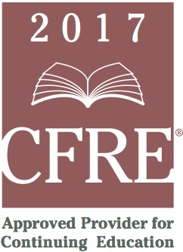
CFRE International has developed this form as a way for you to quickly track (and keep in your files!) the continuing education sessions you have attended. Simply check the boxes next to the sessions you attended. At the end of the conference, add up the total number of hours. Keep this sheet and you will be ready to complete your application form. All of the session slots listed are eligible for continuing education points on your CFRE application for initial certification and/or recertification. Sessions not listed here are not eligible for points.

CONTINUING EDUCATION POINTS TRACKER

Activity Organizer: - Apra
Title of Activity: - Apra Webinar Series
Names of Presenter(s): - Various
Dates and Location: - January – December 2017

Date: 15 May, 2017
Session 1: 12:00pm – 01:00pm (1.0 pts)
- Collective Giving: Philanthropy as a Team Sport

Date: 15 June, 2017
Session 1: 12:00pm – 1:00pm (1.0 pts)
- Getting the Most out of Wealth Screening

Date: 20 July, 2017
Session 1: 12:00pm – 1:00pm (1.0 pts)
- Top 5 Stops Along the Data Journey that Create the Biggest Impact on Your Mission

Date: 26 September, 2017
Session 1: 12:00pm – 1:00pm (1.0 pts)
- Putting Mid-Level Prospects on Your Radar: Helping Often Overlooked Donors Take Flight

Date: 3 October, 2017
Session 1: 12:00pm – 1:00pm (1.0 pts)
- Donor Retention, Churn, and Other KPIs using Tableau

Date: 9 November, 2017
Session 1: 2:00pm – 3:00pm (1.0 pts)
- How to Identify Major Gifts Prospects in Plain Sight

Date: 14 November, 2017
Session 1: 12:00pm – 1:00pm (1.0 pts)
- Are You Still Screening in the Dark Ages? Best Practices for Screening in the 21st Century

Total number of points attained: _______
Date: 19 October, 2017
Session 1: 12:00pm – 1:00pm (1.0 pts)
- Evaluating and Rating Commercial Real Estate Owners

Date: 27 October, 2017
Session 1: 11:00am – 12:00pm (1.0 pts)
- Prospect Development Trends

